Attaching Documentation to a Requisition

Objective
This document provides instructions for attaching a document to a requisition.

Overview
Supplemental information can be attached to a requisition, such as product specifications, written quotes, and so on. These attachments can be viewed by any user who has access to view the requisition; attached documentation can be helpful during the approval process.

Prerequisites
Before you can successfully complete this process, you must ensure that roles granting the necessary permissions have been assigned to your user account. If the roles have not been established, contact the system administrator to have them updated or added into the Munis system.

Confirm the following:
File extensions (for example, .pdf, .doc, .xls) have been created in the System Administration Miscellaneous Codes program.

Procedure
To attach a file:
- Open the Requisition Entry program.
Financials > Purchasing > Purchase Order Processing > Requisition Entry
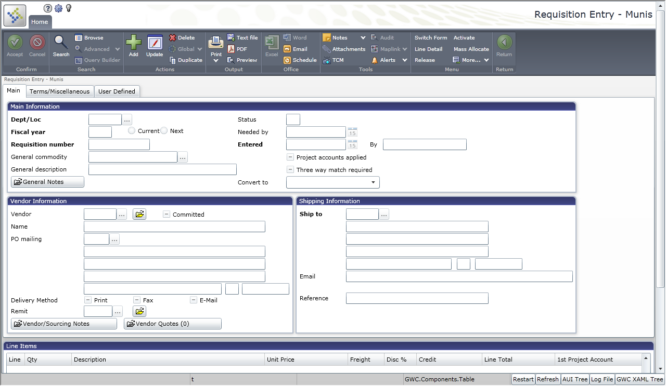
- Click Search on the ribbon.
- Enter any combination of fields, such as requisition number, department code, clerk name, entry date, and so on, to find the requisition to which to attach documentation.
- Click Accept to execute the search.
The program displays the record matching the search criteria.
- Click the Attachments button.
The program displays the Requisitions Attachments screen.
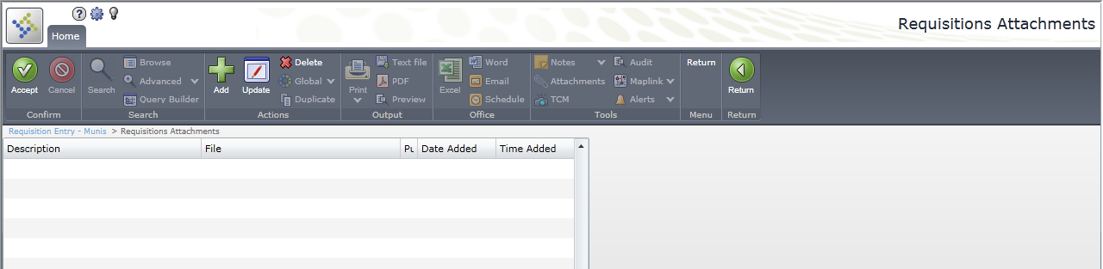
- Click Add on the ribbon.
- Navigate to the file to attach and click Open.
The program displays the Attach File Attributes screen.
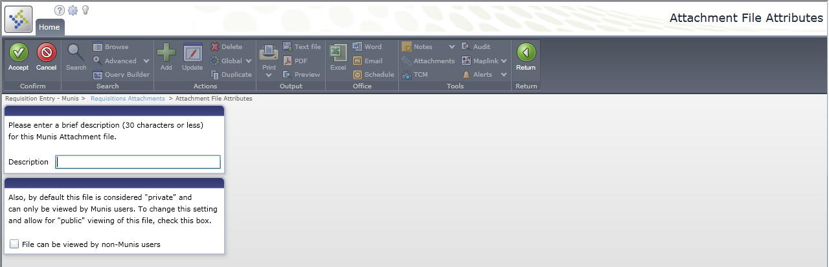
- Enter a description of the file you are attaching, and then select the File Can be Viewed by non-Munis Users check box, if appropriate.
- Click Accept .
The file is attached to the requisition.
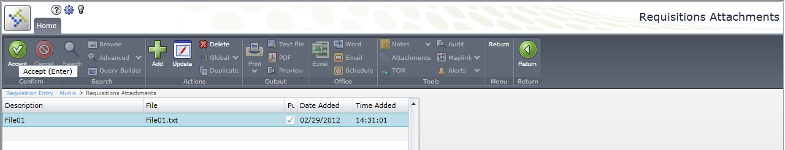
- Click Return to return to the requisition record.
The Attachments link at the bottom of the screen indicates that an attachment is available.
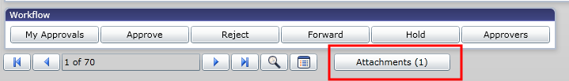

Results
The document is attached to the requisition and the number of attachments for the record displays on the screen.

GL Impact
There is no impact on the general ledger by this function.

What’s Next?
The attachment can be viewed during the approval process and from the Requisition Inquiry program by clicking the Attachments button on the ribbon.

